Plank

You don’t need materials for this exercise. With this you train your chest.

1. Lay on your chest.
2. Lift yourself up with your elbows, arms and feet.
3. Keep yourself still like a plank.
4. Flex your chest.
5. Hold this position for a certain amount of time.

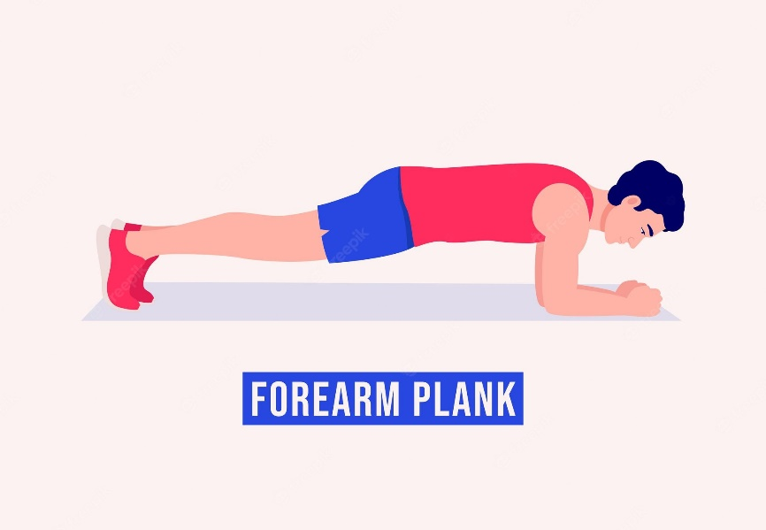

Horsekick

You don’t need materials for this exercise. With this you train your glutes.

1. Go stand up straight.
2. Bend over with your hands to the ground.
3. Hit the grind with your hands and kick one of your legs in de air.
4. While placing your hands on the floor, swing your leg in the air.
5. Repeat this and switch legs.

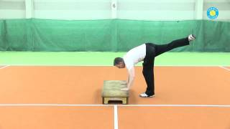

Mountain climbers

You don’t need materials for this exercise. With this you train your glutes, tricep, shoulders and legs.

1. Go lay flat on your chest.
2. Go stand on hands and feet.
3. Keep your body in a straight line.
4. Keep your shoulders over your wrists.
5. Push your knee into your chest.
6. Do this with both legs.

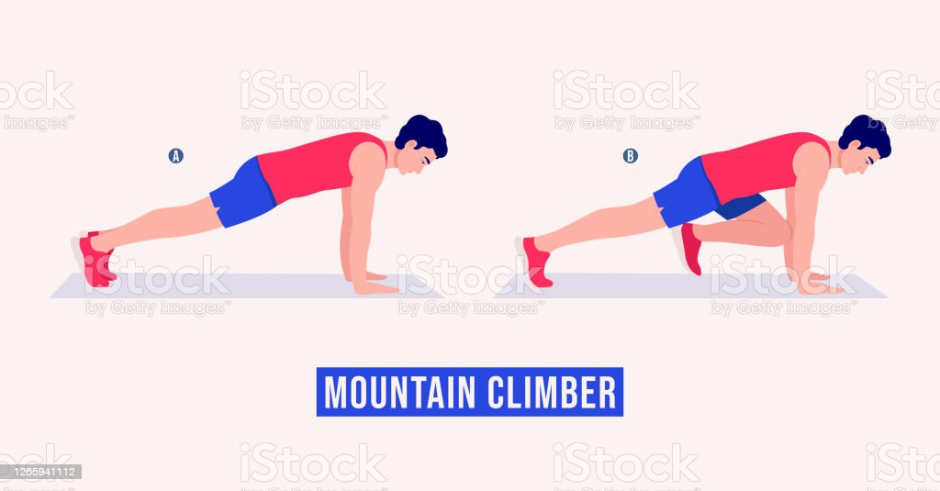

Wall Sit Instruction

When it comes to bodyweight exercises that work your leg muscles, wall sits are one of your best options.

Step 1: Stand with your back against a wall

Step 2: walk your feet 2 feet forward.

Step 3: Then, Slide slowly down the wall until your thighs are parallel.

Step 4: Please keep your feet shoulder-width apart.

Step 5: Make sure that your knees are over your ankles bent at a 90-degree angle.

Step 6: Create a stable position with distributing your weight and grip the floor with your feet

Step 7: Rest your upper body and head against the wall.

Step 8: hold the squat position.



Instruction for beginner Burpee :

The burpee is an almost full body workout that you can perform in the living room.

Step 1: Start in a squatting position, back straight and feet apart.

Step 2: Lower your hands to the ground in front of you inside your feet.

Step 3: With your weight on your hands, kick your feet back to get into a push-up position.

Step 4: Do a push up.

Step 5: Perform a frog kick by jumping your feet back to their starting position.

Step 6: Stand and reach with your arms above your head.

Step 7: Jump into the air so that you land back where you started.

Step 8: Repeat the process.

Lunge instruction

Lunges are allowing you to shape and strengthen almost every muscle in your lower body.

Step 1: Stand tall with feet hip-width.

Step 2: Please take a step forward with your right leg.

Step 3: Try to put your weight forward.

Step 4: Make sure that your heel hit first the floor.

Step 5: Then, lower your body until you feel that your right thigh is parallel.

Step 6: Press with right heel on the floor.

Step 7: Chose your starting position.

Step 8: Repeat step 4,5 with your other side.

Crunch instruction:

This exercise is specific to the abs.

Step 1: Lie on your back.

Step 2: Put your feet on the floor.

Step 3: Bend your knees and place your arms behind your head.

Step 4: Tighten your abs and inhale.

Step 5: Exhale and lift your upper body.

Step 6: Inhale and return to the starting position.

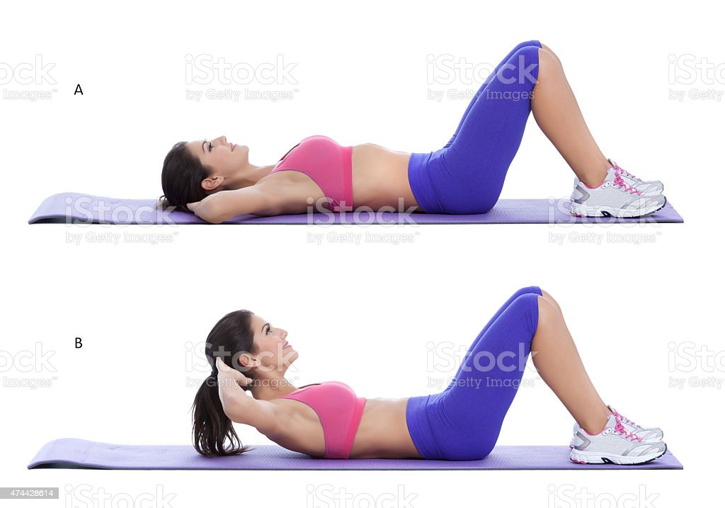

HOW TO DO A SQUAD

You do not need any equipment for this squad. With the squad you train several muscles, but the main muscle groups are your legs and your abdomen. If you want to make the squad even more difficult, you can do it with weights.

1. Place your feet shoulder-width apart.
2. Stretch out your arms and place them at the height of your shoulders.
3. Go down slowly until your legs form an angle of 90 degrees.
4. Pause, then push yourself back up.

You have now completed a successful squad.

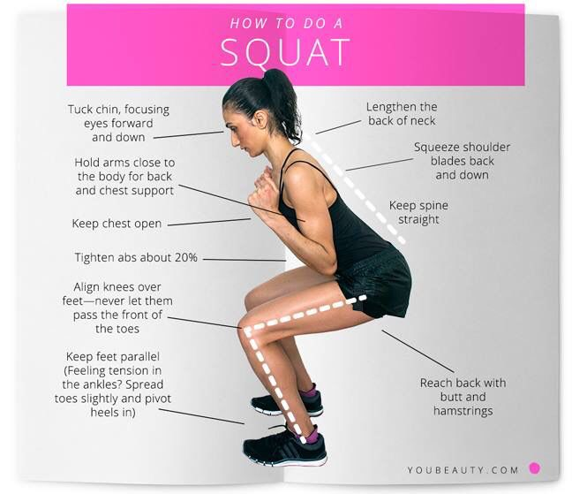

HOW TO DO A PUSH-UP

You don't need any equipment for a push-up. With a push-up you can train many muscles with the different combinations of the push-up. This instruction will explain the normal push-up, which is mainly focused on your chest muscles.

1. Go sit on your knees and place your hands a little further than shoulder width apart.

2. Stretch your legs, make sure only your toes touch the ground.

3. Slowly move down until you reach the ground.

4. Slowly come back up.

You have now completed a successful squad.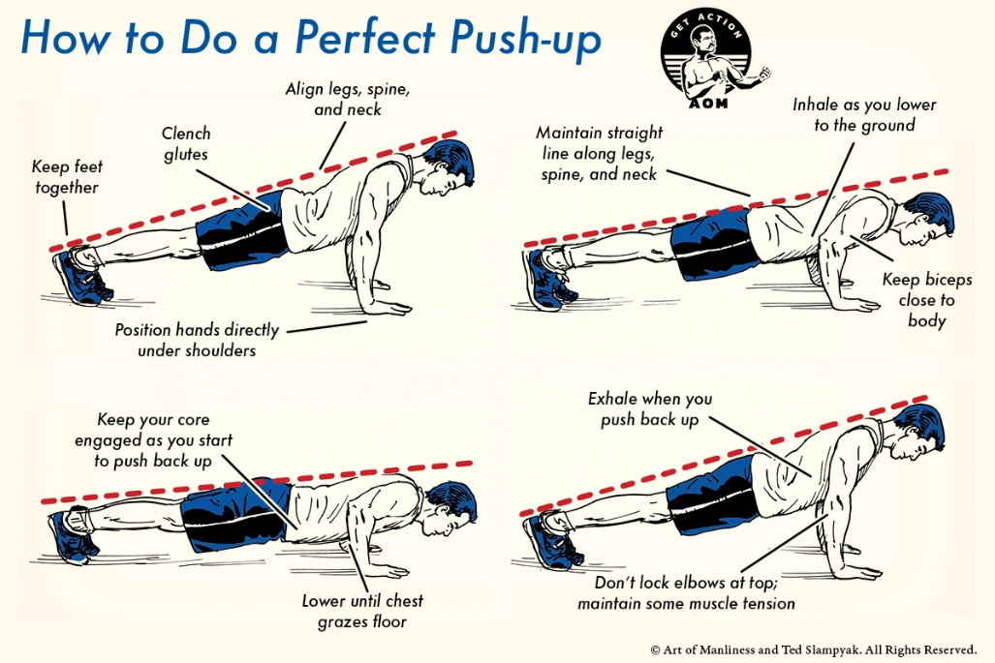

HOW TO DO A DIP

With the dip exercise you need something to hold your hands on in these instructions we assume that you have a table on a chair with which you can do the exercise. With Dips you train mainly your triceps.

1. Put your arms on the chair.

2. Put your heels in and keep your legs stretched.

3. Slowly move your arms down until you reach 90 degrees.

4. Slowly go back up.

You have now completed a successful squad.

